CEE 235A: Final Project

Interim Submission 2

We validated the structure explained in class:

Our ouputs were:

These matched the ones discussed in class for the structure.

We also tested our code on the structure in HW 4, Problem 2:

Our outputs were:

These matched the ones from theory obtained during solving the same by hand.

CEE 235A: Final Project

Interim Submission 3

We validated the structure explained in class:

Our code ouputs compared with the mastan in-built 1st order analysis were:

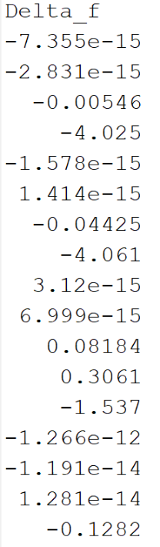

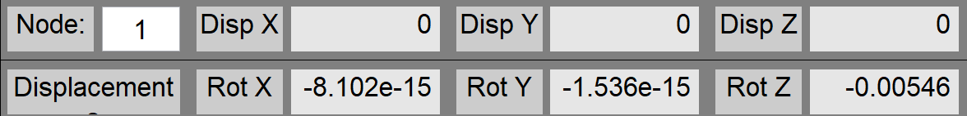

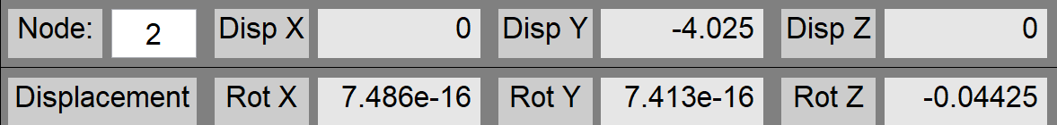

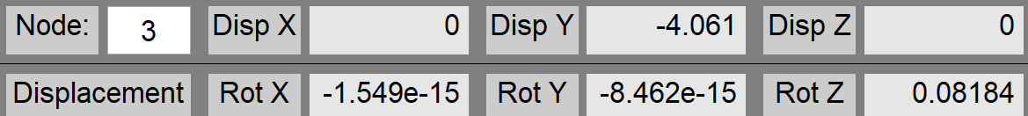

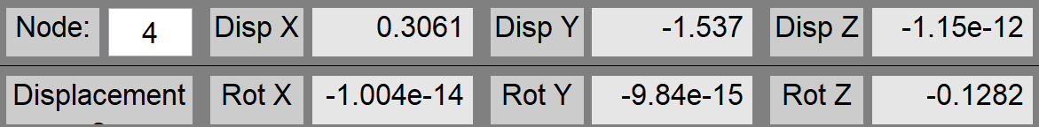

Striked out => DoFs that aren’t free, hence not included in Delta_F. Only the 17 values for free DOF are checked.

Values that are very small (~0) are very small and close to each other in both cases even though they don’t seem to match.







We see that all reaction forces match those from Mastan in-built analysis

We also tested our code on the structure in HW 4, Problem 2:

For the sake of a space frame analysis, we ensure that Iyy and J are non-zero. We set Izz= Iyy = I and J ~ I/5 for this problem.

We compare our code results with MASTAN built in analysis.

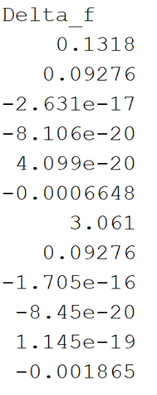

Only free DOFS correspond to nodes 2 and 3.

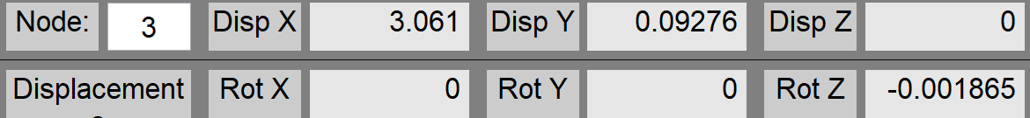

We see that the values match. The values that are really small are almost 0, so they match as well.

For Reaction forces:

These match as well.

Verification Problem 1a:

**FINAL VERIFICATION PROBLEMS**

## c



y

wy (kn/m)

3 m

b

A = 4 x 104 mm2

I = 3.8 x 109 mm4

4 m

A = 2 x 104 mm2

I = 1.5 x 109 mm4

a

E = 200 kN/mm2

d

12 m

A = 2 x 104 mm2

I = 1.5 x 109 mm4

## x

### Notes:

1. The load Wy = 15 kN/m is a vertical distributed load along the length of the member, which you will need to convert to equivalent amounts of distributed load in the local x’ and y’ axis of the member.

### Report the following information:

* + Deflections at points *b* and *c* (x, y, z)
  + Reactions at points *a* and *d* (Fx, Fy, Mz)
  + Sketch of bending moment diagram showing numeric values at member ends and midspan of *b-c*.

**Solution**

Deflections at points b and c (our results are shown up to 6 significant digits)

### point b [WRITE UNITS]

|  |  |  |
| --- | --- | --- |
|  | MASTAN results | your results |
| x | -3.6 mm | -3.59974 mm |
| y | -0.08283 mm | -0.0828263 mm |
| z | 0.0006034 mm/mm | 0.000603418 mm/mm |

**point c [WRITE UNITS]**

|  |  |  |
| --- | --- | --- |
|  | MASTAN results | your results |
| x | -3.715 mm | -3.71541 mm |
| y | -0.007041 mm | -0.00704142 mm |
| z | 0.0002667 mm/mm | 0.000266686 mm/mm |

Reactions at points a and d

### point a [WRITE UNITS]

|  |  |  |
| --- | --- | --- |
|  | MASTAN results | your results |
| Fx | 134.601 kN | 134.6 kN |
| Fy | 82.8263 kN | 82.83 kN |
| Mz | -314459.0 kN mm | -3.145e5 kN mm |

**point d [WRITE UNITS]**

|  |  |  |
| --- | --- | --- |
|  | MASTAN results | your results |
| Fx | 29.1989 kN | 29.2 kN |
| Fy | 4.02367 kN | 4.024 kN |
| Mz | -113625.0 kN mm | -1.136e5 kN mm |

Sketch of bending moment diagram

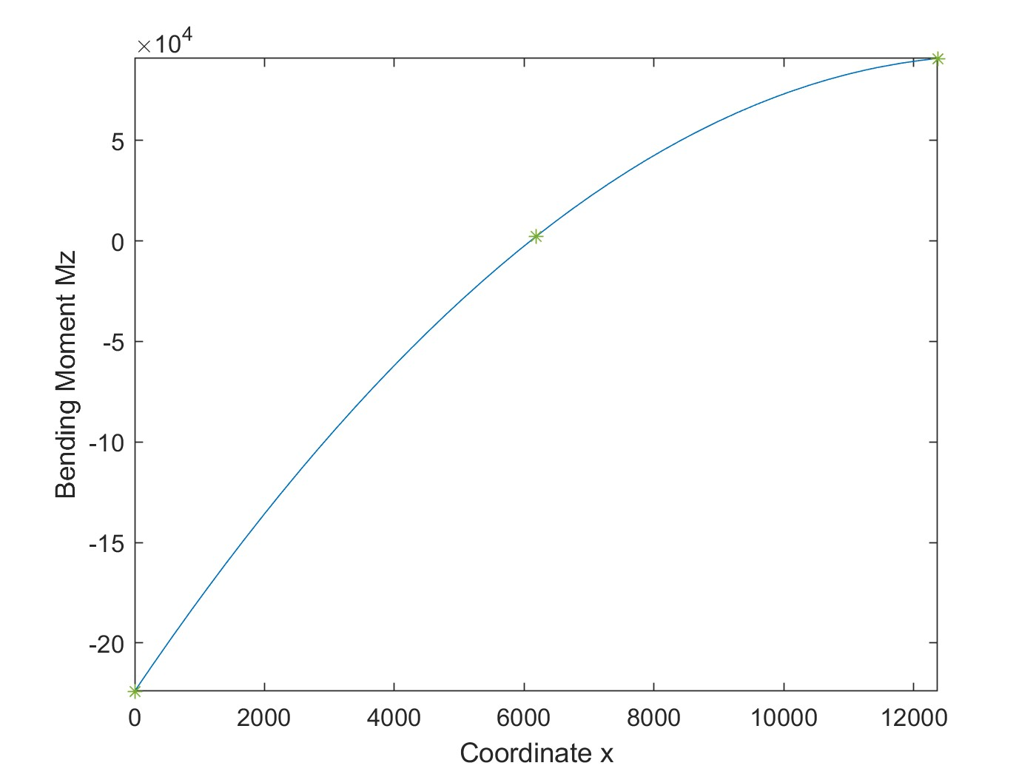

Mz = 90765.9 kN mm

Mz = 2256.42 kN mm

Mz = -223946kN mm

# Verification Problem 1b (Extra Credit):

Repeat Verification Problem 1a for the following cases:

1. The *left end* of member *bc* is flexurally released.
2. The *right end* of member *bc* is flexurally released.

### Verification Problem 1b-1 (Left end of member *bc* released)

Deflections at points b and c

### point b [WRITE UNITS]

|  |  |  |
| --- | --- | --- |
|  | MASTAN results | your results |
| x | -8.213 mm | -8.21254 mm |
| y | -0.06216 mm | -0.0621645 mm |
| z | 0.00308 mm/mm | -0.0000547257 mm/mm |

**point c [WRITE UNITS]**

|  |  |  |
| --- | --- | --- |
|  | MASTAN results | your results |
| x | -8.276 mm | -8.27646 mm |
| y | -0.0432 mm | -0.0431996 mm |
| z | 0.00105 mm/mm | 0.00104956 mm/mm |

Reactions at points a and d

### point a [WRITE UNITS]

|  |  |  |
| --- | --- | --- |
|  | MASTAN results | your results |
| Fx | 115.5 kN | 115.489 kN |
| Fy | 62.16 kN | 62.1645 kN |
| Mz | -4.62e5 kN mm | -461955.0 kN mm |

**point d [WRITE UNITS]**

|  |  |  |
| --- | --- | --- |
|  | MASTAN results | your results |
| Fx | 48.31 kN | 48.3112 kN |
| Fy | 24.69 kN | 24.6855 kN |
| Mz | -2.141e5 kN mm | -214070.0 kN mm |

Sketch of bending moment diagram

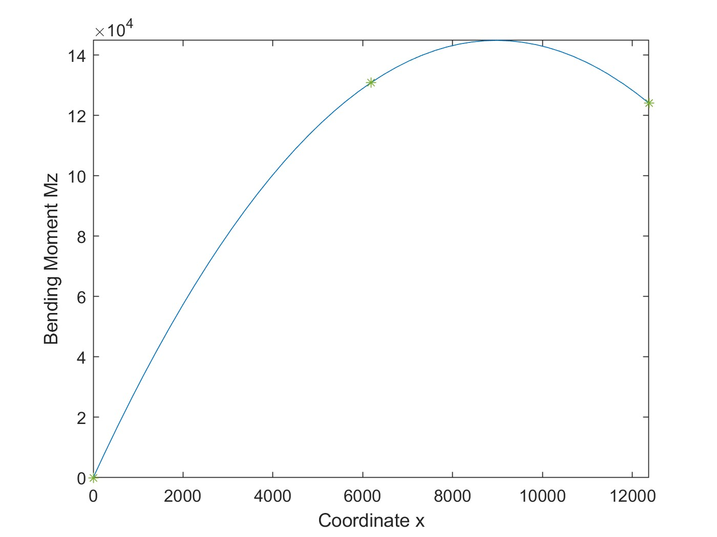

Mz = 130902 mm

Mz = 124112 kN mm

Mz = 0 kN mm

Deflections at points b and c

### point b [WRITE UNITS]

|  |  |  |
| --- | --- | --- |
|  | MASTAN results | your results |
| x | -4.514 mm | -4.51377 mm |
| y | -0.08043 mm | -0.0804289 mm |
| z | 0.0009094 mm/mm | 0.000909412 mm/mm |

**point b [WRITE UNITS]**

|  |  |  |
| --- | --- | --- |
|  | MASTAN results | your results |
| x | -4.653 mm | -4.65312 mm |
| y | -0.001124 mm | -0.0112369 mm |
| z | 0.0009971 mm/mm | 0.000997098 mm/mm |

Reactions at points a and d

### point a [WRITE UNITS]

|  |  |  |
| --- | --- | --- |
|  | MASTAN results | your results |
| Fx | 151.6 kN | 151.591 kN |
| Fy | 80.43 kN | 80.4289 kN |
| Mz | -3.714e5 kN mm | -371387.0 kN mm |

**point d [WRITE UNITS]**

|  |  |  |
| --- | --- | --- |
|  | MASTAN results | your results |
| Fx | 12.21 kN | 12.2094 kN |
| Fy | 6.421 kN | 6.42106 kN |
| Mz | -8.547e4 kN mm | -85465.5 kN mm |

Sketch of bending moment diagram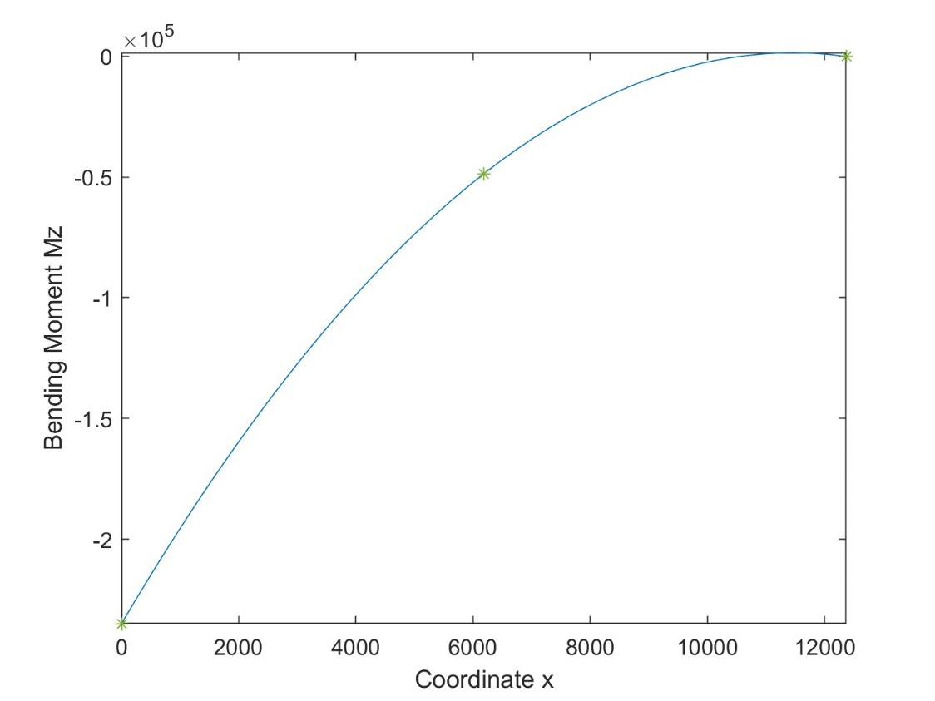

Mz =-48636.4 kN mm

Mz =0 kN mm

Mz =-234975 kN mm

# Verification Problem 2:



3 m

d

c

z

y

wz (kn/m)

8 m

a

x

b

5 m

### Notes:

1. The structure consists of a horizontal grid of rectangular tubular members measuring 100 mm wide x 300 mm deep. The members are all oriented with their tall dimension (web direction or local y axis) parallel to the global z-axis (vertical direction). The tubular members have the following properties: A = 11,000 mm2, Izz= 1.06 x 108 mm4, Iyy= 1.74 x 107 mm4 , J = 5.29 x 107 mm4
2. Members are steel with E = 200 kN/mm2 and  = 0.3.
3. The load Wz = 5 kN/m is a vertical distributed load along the length of the member.

### Report the following information:

* + Deflections at point b (x, y, z, z, y, z)
  + Reactions at point a (Fx, Fy, Fz, Mx, My, Mz)
  + Value of torsion (Mx’) in member a-b.
  + Sketch diagram of major axis bending moment for each member with key numerical values indicated.

**Solutions**

Deflections at point b

### point b [WRITE UNITS]

|  |  |  |
| --- | --- | --- |
|  | MASTAN results | your results |
| x | 2.18203e-15 mm | 1.84e-18 mm |
| y | -2.92599e-15 mm | -2.263e-15 mm |
| z | -35.503 mm | -35.5 mm |
| x | -0.00107847 mm/mm | -0.001078 mm/mm |
| y | 0.0104828 mm/mm | 0.01048 mm/mm |
| z | -5.35138e-19 mm/mm | -3.801e-19 mm/mm |

Reactions at point a

### point a [WRITE UNITS]

|  |  |  |
| --- | --- | --- |
|  | MASTAN results | your results |
| Fx | -2.40499e-15 kN | -8.095e-16 kN |
| Fy | 1.44372e-15 kN | 1.407e-15 kN |
| Fz | 18.9192 kN | 18.92 kN |
| Mx | 877.709 kN mm | 877.7 kN mm |
| My | -91745.0 kN mm | -9.174e04 kN mm |
| Mz | 5.10005e-12 kN mm | 6.056e-12 kN mm |

Value of torsion Mx’

|  |  |  |
| --- | --- | --- |
| Member: | MASTAN results | your results |
| a-b | -877.709 kN mm | -877.7 kN mm |

Sketch of bending moment diagram

Member 1:

Mz = 2851 kN mm

Mz = -91745 kN mm

Member 2

Mz = 34915.9 kN mm

Mz = -9524.11 kN mm

Mz =-877.709 kN mm

Member 3

Mz =-66093.2 kN mm

Mz =-2850.84 kN mm

# Verification Problem 3 – Swing Set:



**Px**

d

2.5 m

c

z

y

3 m

b

x

1 m

1 m

## a

### Notes:

1. The structure is built with round 75 mm diameter tubular members have the following properties: A = 1,430 mm2, I = 1.26 x 106 mm4, J = 2.52 x 106 mm4
2. Members are steel with E = 200 kN/mm2 and  = 0.3.
3. The load Px = 4.5 kN at node d is applied in the global x direction at the mid-span of the horizontal member.

### Report the following information:

* + Deflections at point d (x, y, z, z, y, z)
  + Reactions at points a and b (Fx, Fy, Fz, Mx, My, Mz)
  + Axial forces in members a-c, c-b, and c-d.

**Solution**

Deflections at point d

### point d

|  |  |  |
| --- | --- | --- |
|  | MASTAN results | your results |
| x | 7.744 mm | 7.74411 mm |
| y | -1.601e-32 mm | 0.0000891948 mm |
| z | -1.426e-20 mm | 0.0000535169 mm |
| x | -1.608e-36 mm/mm | -3.56779e-8 mm |
| y | 2.648e-05 mm/mm | -0.0000239967 mm/mm |
| z | -1.844e-19 mm/mm | -0.00687496 mm/mm |

Reactions at points a and b

Mx, My, Mz correspond to free DOFs, hence reactions are zero.

### point a

|  |  |  |
| --- | --- | --- |
|  | MASTAN results | your results |
| Fx | -1.125 kN | -1.14504 kN |
| Fy | -0.2662 kN | -0.266247 kN |
| Fz | -2.813 kN | -2.80384 kN |
| Mx | -- | -- |
| My | -- | -- |
| Mz | -- | -- |

**point b**

|  |  |  |
| --- | --- | --- |
|  | MASTAN results | your results |
| Fx | -1.125 kN | -1.14504 kN |
| Fy | 0.2662 kN | 0.266252 kN |
| Fz | 2.813 kN | 2.80374 kN |
| Mx | -- | -- |
| My | -- | -- |
| Mz | -- | -- |

Axial forces

|  |  |  |
| --- | --- | --- |
|  | MASTAN results | your results |
| a-c | 3.029 kN | 3.02856 kN |
| c-b | -3.029 kN | -3.02845 kN |
| c-d | -1.221e-17 kN | -5.87623e-8 kN |

# Verification Problem 4a:

### Notes:

1. Since this is a 2D problem, you will have to restrain the structure in the out-of-plane direction. In other words, you will restrain translation in the global z-direction and rotation about the global x and y axes.
2. Members have the following properties:

W36 x 150: A=44.2 in2, I = 9,040 in4, Aweb = 22.4 in2 W14 x 211: A=62.0 in2, I = 2,660 in4, Aweb = 15.7 in2

1. Members are steel with E = 30,000 k/in2 and  = 0.3.
2. The applied lateral load at each floor is Px = 9.5 kips
3. Base your analysis on centerline dimensions (i.e., ignoring finite joint size effects).

### Perform two lateral load analyses, one in which shear deformations are included and one in which they are excluded. Report the following information for each analysis

* + Lateral deflections at each floor level (xa, xb, xc)
  + The maximum moments in column a-b and beam b-e.
  + What is the percentage change in lateral deflections due to the shear deformations?
  + What is the percentage change in the *maximum* beam and column moments due to shear deformations?

**Solution:**

**Include shear deformation**

Lateral deflections at each floor level

|  |  |  |
| --- | --- | --- |
|  | MASTAN results | your results |
| x3 (Roof) | 0.113 in | 0.113034 in |
| x2 (3F) | 0.09067 in | 0.090669 in |
| x1 (2F) | 0.04813 in | 0.0481261 in |

The maximum moments

|  |  |  |
| --- | --- | --- |
|  | MASTAN results | your results |
| column a-b | 324.7 kip-in | 324.726 kip-in |
| beam b-e | 429.7 kip-in | 429.675 kip-in |

### Exclude shear deformation

Lateral deflections at each floor level

|  |  |  |
| --- | --- | --- |
|  | MASTAN results | your results |
| x3 (Roof) | 0.09695 in | 0.096948 in |
| x2 (3F) | 0.07769 in | 0.0776854 in |
| x1 (2F) | 0.0409 in | 0.040904 in |

The maximum moments

|  |  |  |
| --- | --- | --- |
|  | MASTAN results | your results |
| column a-b | 316.2 kip-in | 316.205 kip-in |
| beam b-e | 422.4 kip-in | 422.441 kip-in |

**Comparison**

The percentage change in lateral deflection change [ = 100 * (x_include - x_exclude)/ x_include ]

|  |  |
| --- | --- |
|  | your results |
| x3 (Roof) | 14.23 % |
| x2 (3F) | 14.32 % |
| x1 (2F) | 15.01 % |

The percentage change in the maximum moments [ = 100 * (_include - _exclude)/ _include ]

|  |  |
| --- | --- |
|  | your results |
| column a-b | 2.62 % |
| beam b-e | 1.68 % |

# Verification Problem 4b (Extra Credit):

Repeat Verification Problem 4a for the case where both ends of beams a-d, b-e and c-f are flexurally released.

### Verification Problem 4b

1. **include shear deformation**

Lateral deflections at each floor level

|  |  |  |
| --- | --- | --- |
|  | MASTAN results | your results |
| x3 (Roof) | 0.1507 in | 0.15069 in |
| x2 (3F) | 0.1168 in | 0.116797 in |
| x1 (2F) | 0.05722 in | 0.0572165 in |

The maximum moments

|  |  |  |
| --- | --- | --- |
|  | MASTAN results | your results |
| column a-b | 101.2 kip-in | 101.227 kip-in |
| beam b-e | 0 kip-in | 0 kip-in |

### exclude shear deformation

Lateral deflections at each floor level

|  |  |  |
| --- | --- | --- |
|  | MASTAN results | your results |
| x3 (Roof) | 0.1305 in | 0.130484 in |
| x2 (3F) | 0.1013 in | 0.101338 in |
| x1 (2F) | 0.04921 in | 0.0492134 in |

The maximum moments

|  |  |  |
| --- | --- | --- |
|  | MASTAN results | your results |
| column a-b | 96.56 kip-in | 96.56 kip-in |
| beam b-e | 0 kip-in | 0 kip-in |

The percentage change in lateral deflection change [ = 100 * (x_include - x_exclude)/ x_include ]

|  |  |
| --- | --- |
|  | your results |
| x3 (Roof) | 10.52 % |
| x2 (3F) | 11.49% |
| x1 (2F) | 13.99% |

The percentage change in the maximum moments [ = 100 * (_include - _exclude)/ _include ]

|  |  |
| --- | --- |
|  | your results |
| column a-b | 4.61% |
| am b-e | 0 % |

# 

# Verification Problem 5:

e

f W36 x 150 (typ.)

a

b

c

d

30 ft (typ)

W14 x 211 (typ.)

### Notes:

13 ft (typ)

1. This is the same structure as for Problem 4.
2. For this problem, do NOT include member shear deformations.

### Perform an analysis where you apply a vertical settlement of  = -1 inch to the support at point b. Report the following information from this analysis.

* + Base reactions at points a, b, c, and d (Fx, Fy, M)
  + Shear and moments in beam e-f (V, Me, Mf).

### Problem 5

Base reactions at points a, b, c and d

**point a**

|  |  |  |
| --- | --- | --- |
|  | MASTAN results | your results |
| Fx | 22.76 kips | 22.7618 kips |
| Fy | 125.1 kips | 125.051 kips |
| Mz | -844.4 kip-in | -844.411 kip-in |

**point b**

|  |  |  |
| --- | --- | --- |
|  | MASTAN results | your results |
| Fx | -11.9 kips | -11.8976 kips |
| Fy | -285.2 kips | -285.2108 kips |
| Mz | 982.2 kip-in | 982.198 kip-in |

**point c**

|  |  |  |
| --- | --- | --- |
|  | MASTAN results | your results |
| Fx | -34.1 kips | -34.0952 kips |
| Fy | 178.8 kips | 178.769 kips |
| Mz | 2160 kip-in | 2160.23 kip-in |
|  |  |  |

**point d**

|  |  |  |
| --- | --- | --- |
|  | MASTAN results | your results |
| Fx | -5.269 kips | -5.26907 kips |
| Fy | -18.61 kips | -18.609 kips |
| Mz | 653.9 kip-in | 653.898 kip-in |

Shear and moments in beam e-f

|  |  |  |
| --- | --- | --- |
|  | MASTAN results | your results |
| V | 43.17 kips | 43.1716 kips |
| Me | 6480 kips | 6479.59 kips |
| Mf | 9062 kip-in | 9062.17 kip-in |

Project contribution:

Both Mrunmayi and Devasmit have equally contributed this project as a whole.

Primarily, Devasmit was in charge of formulating the fundamental code base (computation of stiffness, deflection, reactions, etc.), with assist from Mrunmayi on creation post-processing functions (member forces, member force variations). Both worked simultaneously to crack the extra-credit computation.

Mrunmayi was primarily in charge of the data-collection and verification problems, with assist from Devasmit in validations, more complex situations and required code debugging. Both worked together on the final report submission